**Case study: Lane Detection for Autonomous Vehicles using Computer Vision Algorithm**

**Roll Name Name**

CB.EN.P2AID20002 Abhishek Gopinath

CB.EN.P2AID20010 Alan Henry

CB.EN.P2AID20024 Jiss Joseph Thomas

**General Instruction:**

1. For each heading place your contents
2. Refer URL’s wherever specified and place your result.
3. Place screenshots wherever required and present your understanding from the output.
4. Can also refer additional references wherever required

**1. Problem Statement/Objective:**

To detect lanes on the given dataset of video or images of roads or as real time, using computer vision algorithms which could be helpful in proper implementation of autonomous driving.

**2. Dataset Description**

The dataset given to our problem statement could be either as a set of images of as video format. There are more than 1000 images for dataset containing images and two or three videos for detecting the same.

**Sample images:**

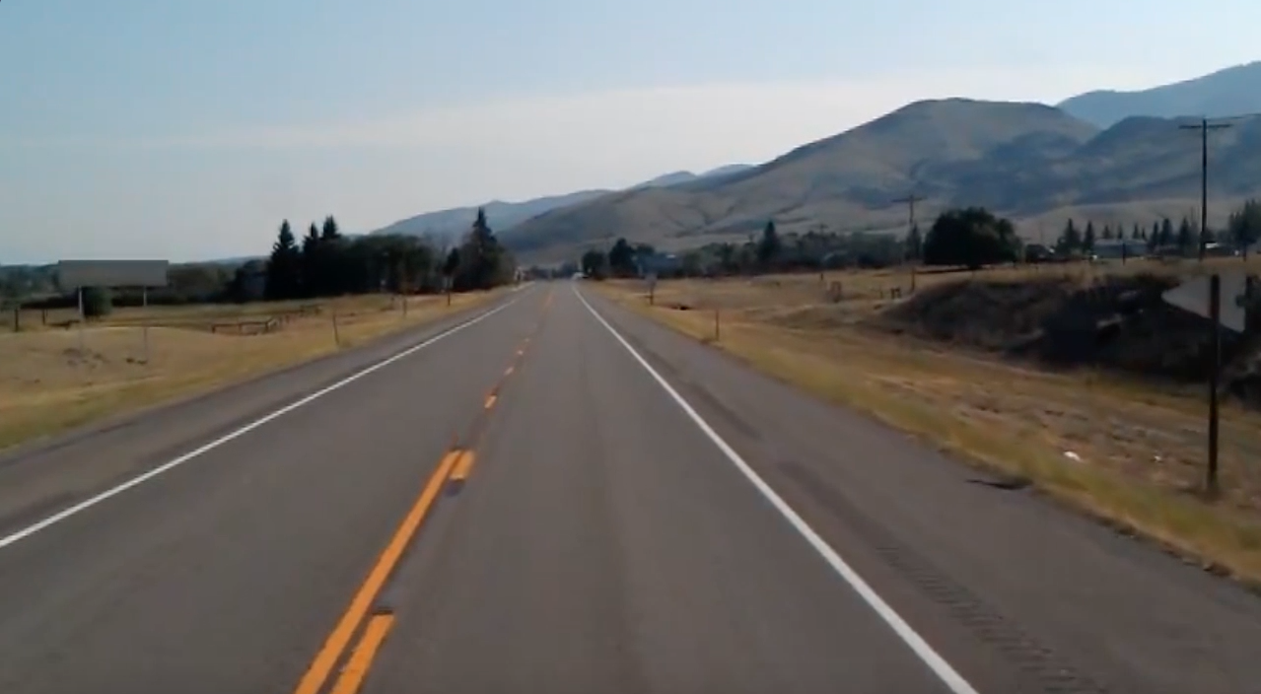

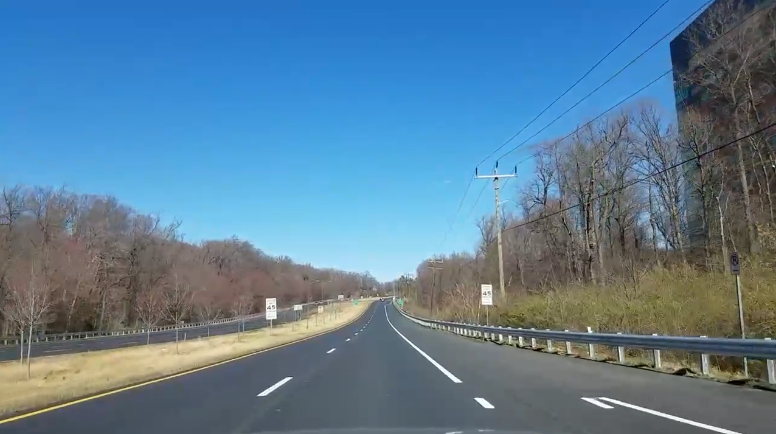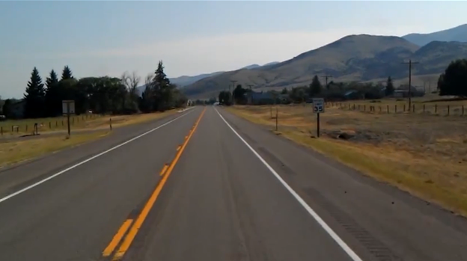

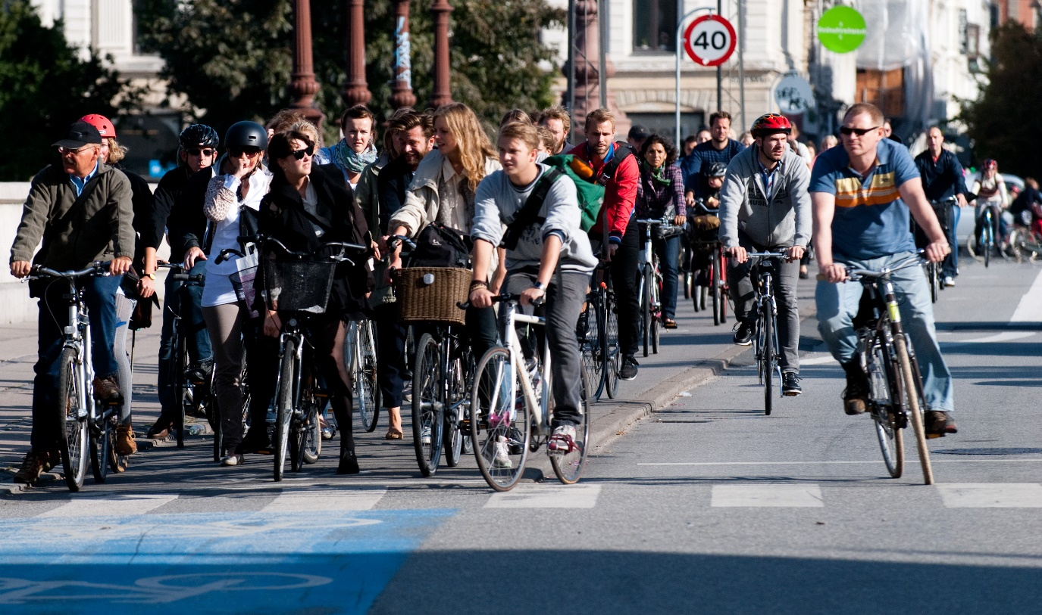

3. Analytical Questions/Statistical Questions/Prediction level Question

**Analysis [10 questions]**

1.How many vehicles in the frame

2. what are the objects detected in it

3. How many pedestrians are detected in it

4. Detecting road signs.

5. Objects on the interest area.

6. Lines inside the interest area.

7. Traffic signals detected

8. Wet area inside the interest area.

9. Dividers inside the frame.

10. How far the lanes to be detected.

**Analytics [Historical data] [10 questions]**

1. Why vehicles are less in specific area

2. Why more pedestrians are found at certain point

3. Why the road is wet?

4. What type of road we are traveling on.

5. What time do most people drive

6. Do people dim their light while passing

7. How often a certain route is taken.

8. How many speed breakers detected to analyze whether there is school nearby.

9. Why there is no horn sign detected

10. Why vehicle in the front is slowing down

4. Block Diagram

5. Preprocessing

5.a Image Processing in Spatial Domain (Filter)

**Image Smoothing**

* ***Average Filter***

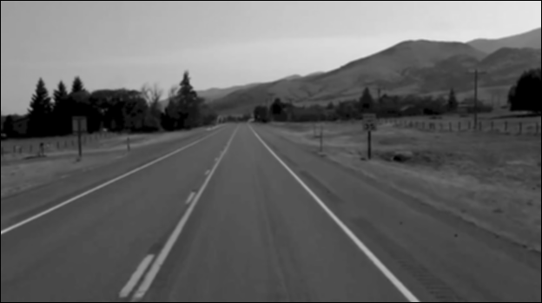

* ***Weighted Average Filter***

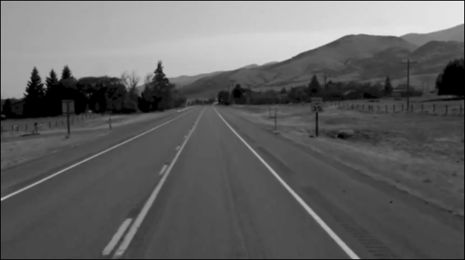

* ***Gaussian Blurring***

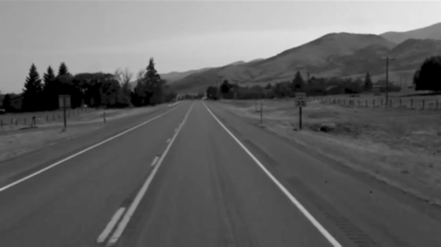

* ***Median Filter***

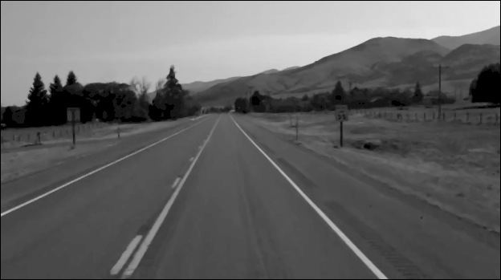

* ***Image Sharpening***

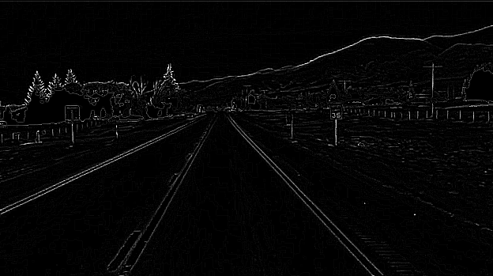

* ***Roberts Filter***

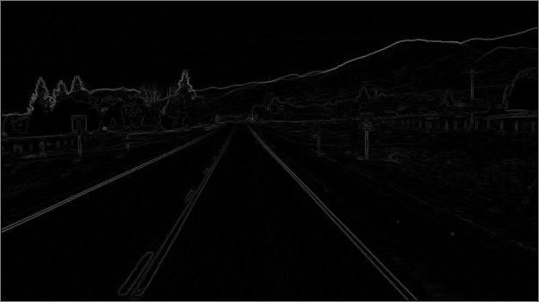

* ***Sobel Filter***

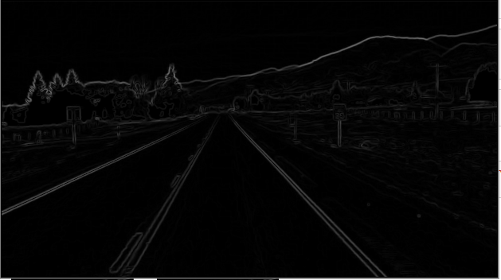

* ***Gamma Transform***

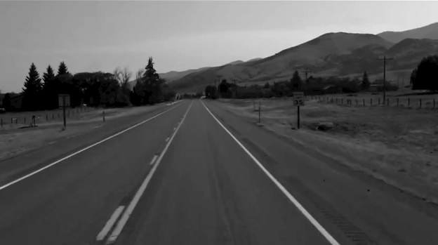

* ***Log Transform***

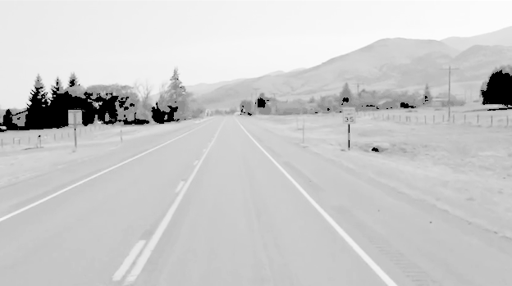

Details)

5.b Image Processing in Frequency Domain (Filter Details)

6.List of Features

[refer : <https://en.wikipedia.org/wiki/Feature_(computer_vision)>

<https://freecontent.manning.com/the-computer-vision-pipeline-part-5-classifier-learning-algorithms-and-conclusion/>]

<https://freecontent.manning.com/the-computer-vision-pipeline-part-5-classifier-learning-algorithms-and-conclusion/>]

|  |  |  |
| --- | --- | --- |
| Feature Name | Purpose | Category  [Image/Vision] |
| Color |  |  |
| Shape |  |  |
|  |  |  |
|  |  |  |
|  |  |  |

7.Feature Detection and Tracking

[Provide algorithm, output and observation from output]

a SIFT

SURF

Harris Corner

Multiscale Oriented PatcheS descriptor

8.Scene

[Place some sample images]

[Describe the scene with the image and list the objects to be identified]

[Make sure that human face also appears in the image]

9.List of Objects in scene and the features

**[Refer section 8 and present the table contents for section 9]**

|  |  |
| --- | --- |
| Object Name | List of features for the object |
| Chair | Shape  Color  ,,,, |
|  |  |
|  |  |
|  |  |
|  |  |

10.Face Detection

[Place the viola Jones algorithm]

[Place the results of the viola jones algorithm for your scene]

11.Refer internet and fill the following related to face detection algorithms and Deep learning architecture

[A sample entry has been provided. Can also include algorithms related to violajones,adaboost classifier also]

|  |  |  |  |
| --- | --- | --- | --- |
| Face Detection Algorithm | URL | Dataset | Deep learning architecture |
| Facenet | <https://machinelearningmastery.com/how-to-develop-a-face-recognition-system-using-facenet-in-keras-and-an-svm-classifier/#:~:text=FaceNet%20is%20a%20face%20recognition,of%20face%20recognition%20benchmark%20datasets.&text=About%20the%20FaceNet%20face%20recognition,implementations%20and%20pre%2Dtrained%20models>. |  | Facenet |
|  |  |  |  |
|  |  |  |  |
|  |  |  |  |
|  |  |  |  |

12.

Performance Metrics

[refer URL: https://towardsdatascience.com/20-popular-machine-learning-metrics-part-1-classification-regression-evaluation-metrics-1ca3e282a2ce]

|  |  |  |  |
| --- | --- | --- | --- |
| **Metric** | **Category** | **Purpose** | **Formula** |
|  |  |  |  |
|  |  |  |  |
|  |  |  |  |
|  |  |  |  |
|  |  |  |  |
|  |  |  |  |
|  |  |  |  |

13.Deep Learning Architectures

[Identify the applications where the deep learning architectures has been applied]

[refer DL_1.pdf]

[refer : <https://developer.ibm.com/technologies/artificial-intelligence/articles/cc-machine-learning-deep-learning-architectures/>]

[refer: https://www.analyticsvidhya.com/blog/2017/08/10-advanced-deep-learning-architectures-data-scientists/]

|  |  |  |  |  |
| --- | --- | --- | --- | --- |
| Architecture Name | Category | Learning | Year of Design | Applications |
| LSTM | RNN | Supervised Learning |  |  |
|  |  |  |  |  |
|  |  |  |  |  |
|  |  |  |  |  |

14.Training ,Testing and Validation

[Place the contents that is under :

<https://lionbridge.ai/training-data-guide/>]

[Provide your inference for 10-rule]

**References**

1. URL of the dataset
2. https://tryolabs.com/resources/introductory-guide-computer-vision/